***_______________________PRAKTIKUM_GUI2__________________________***

**Nama : Khoirul Hanif B**

**Kelas : XII RPL B**

**Absen : 28**

**tUGAS 1**

**Menghitung Mahasiswa**

**Desain Interface**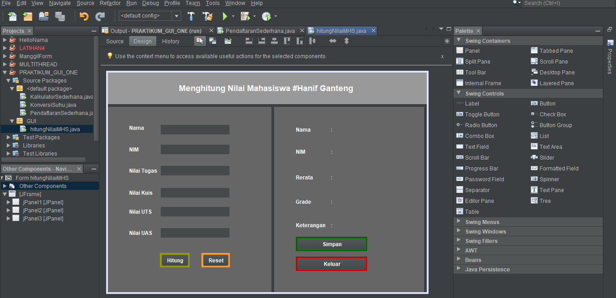

**SOURCE CODE**button(HITUNG)

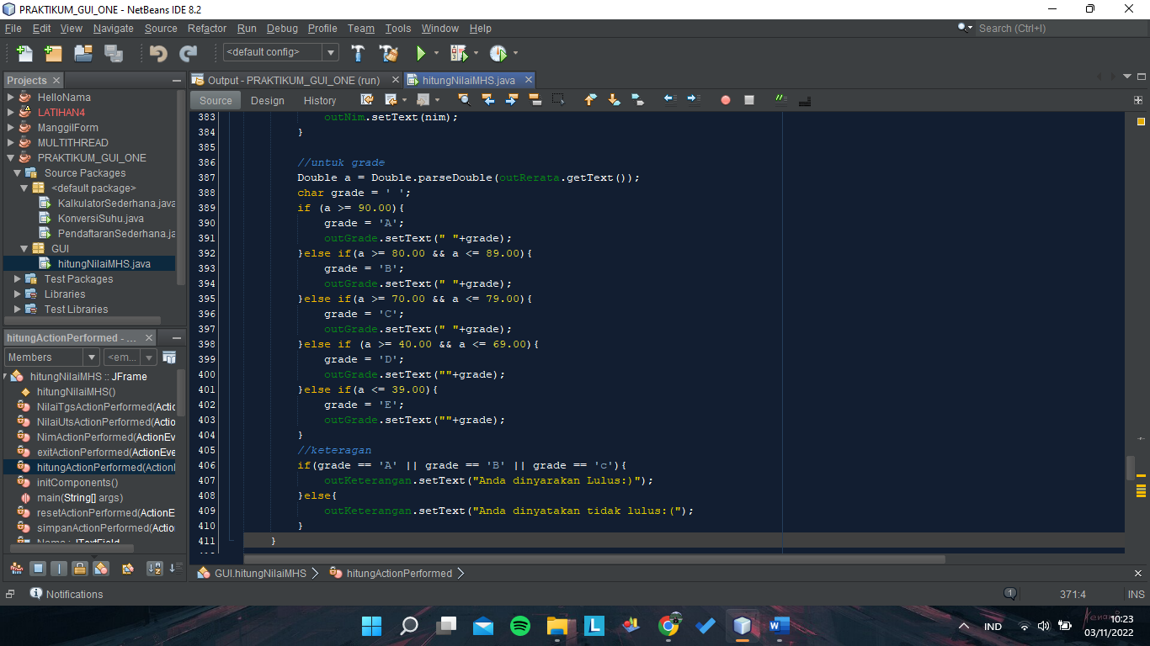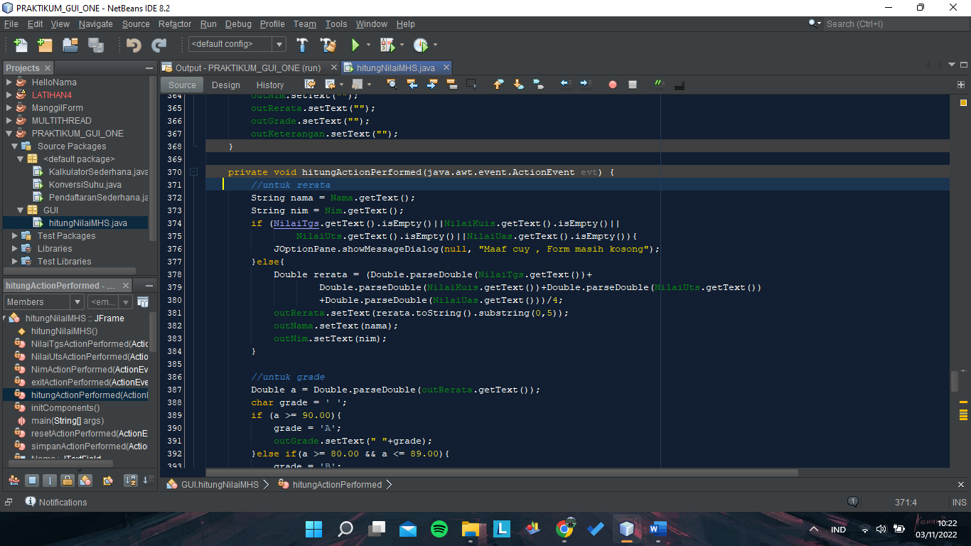

button(RESET)  
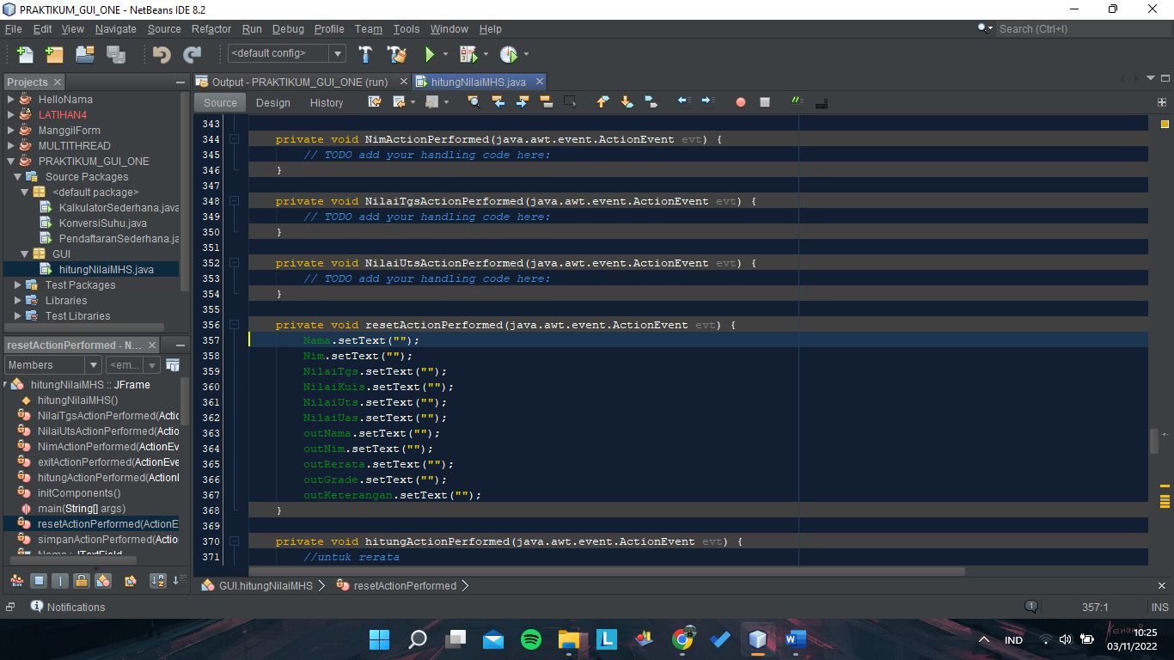

button(SIMPAN)

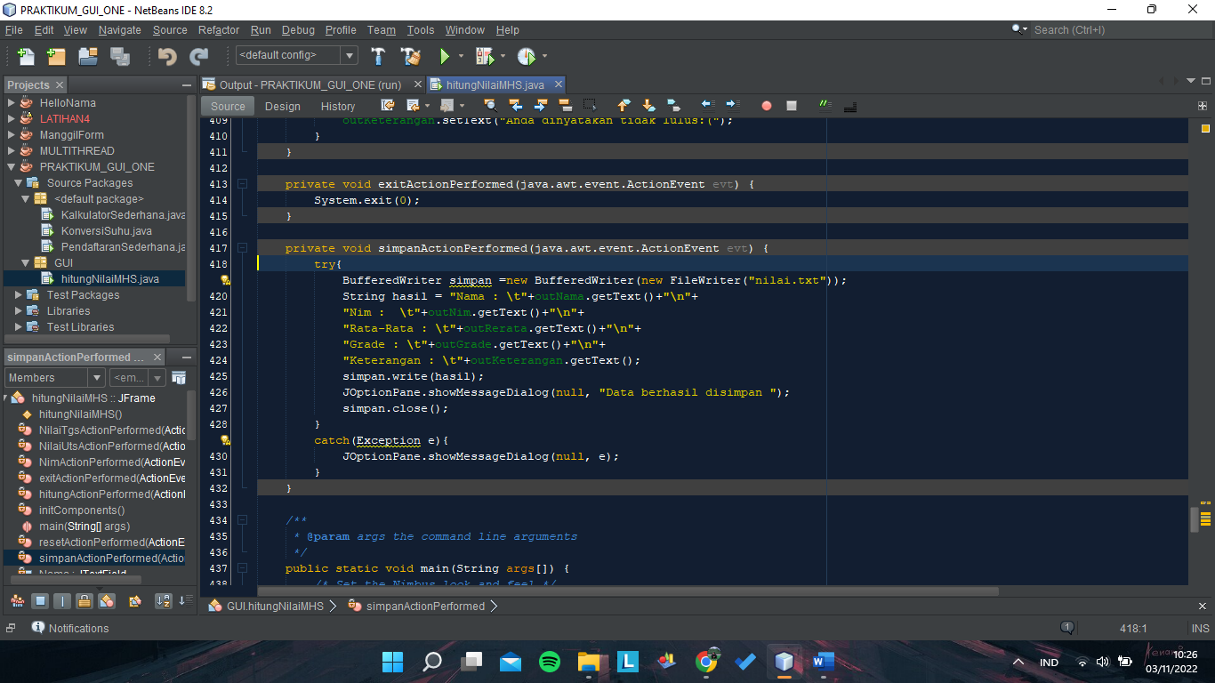

button(EXIT)

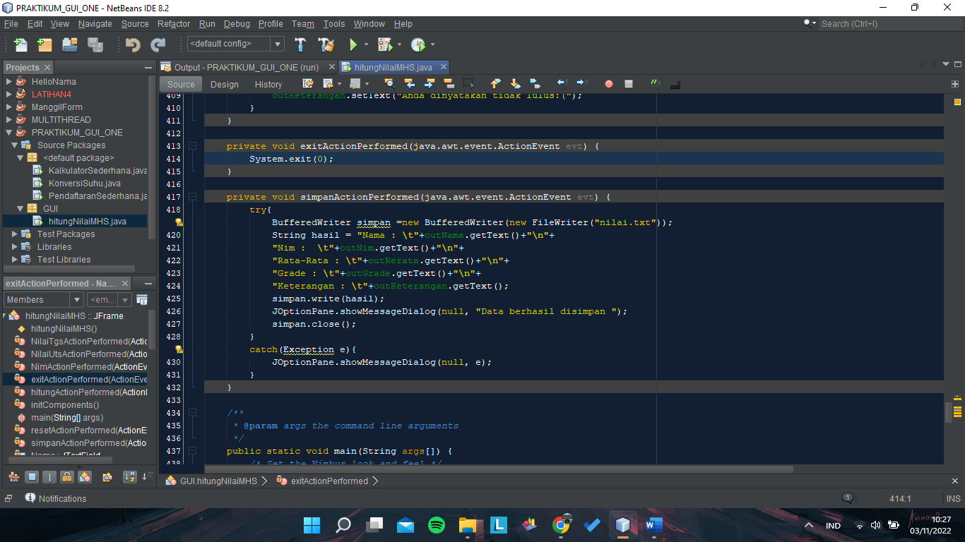

TESTING

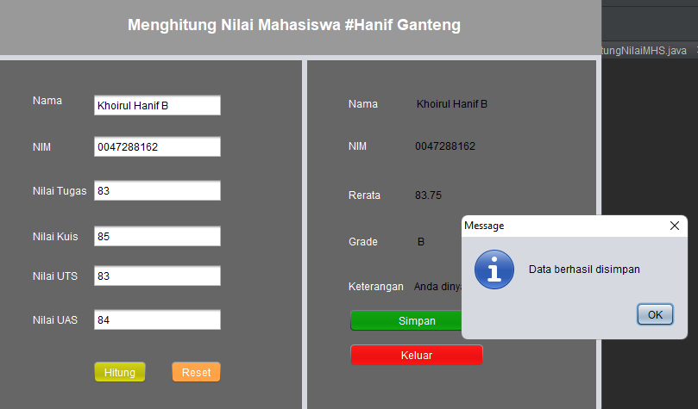

Hasil

